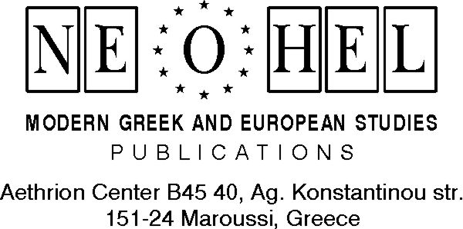

FROM: Evangelia Georgantzi, President /Program Director of NEOHEL
SUBJECT: EU Commission funding programs (COMENIUS 2/ GRUNDTVIG3) for teachers

We should like to inform you about the seminars we organize for 2008 in Athens and in the island of Aegina. In attachment you will find detailed information about the subjects of the training events, the dates and the deadlines for the submission of your demands for grant to the Socrates National Agencies.
We should be grateful if you also communicate this information to your colleagues.
For any further information don’t hesitate to contact us.

Thank you in advance for your assistance.

Georgantzi Evangelia
Program director
(Tel: ++30 6932 438082)

NEOHEL
Modern Greek & European Studies - Publications
www.asteriasbooks.com
Voice:+30.210.6198903 et. 229
Fax: +30.210.6104284
mailto:asteriasbooks@qualco.gr

.

